EXPT NO: 7 | Implementation of Bayesian Networks in Python
DATE: 23.09.2025

PRE-LAB QUESTIONS (Write the answers in your AI and Automation Notebook)
- What is a Bayesian Network, and how does it represent relationships among variables?
A Bayesian Network is a graphical model representing probabilistic relationships among variables using nodes for variables and directed edges for conditional dependencies.

- What is a Conditional Probability Distribution (CPD) in Bayesian Networks?
A Conditional Probability Distribution (CPD) defines the probability of a node’s possible values given the states of its parent nodes in the network.

- How are nodes and edges used in Bayesian Networks?
In Bayesian Networks, nodes represent random variables, while directed edges indicate conditional dependencies, showing how one variable probabilistically influences another.

- Why are Bayesian Networks useful for reasoning under uncertainty?
Bayesian Networks handle uncertainty by combining probability theory and graph structure, enabling reasoning, prediction, and decision-making with incomplete or uncertain information.

- Give two real-world applications of Bayesian Networks.
Real-world applications include medical diagnosis for predicting diseases and spam filtering in emails using probabilistic reasoning to classify messages accurately.

IN-LAB EXERCISE
OBJECTIVE:
To implement a Bayesian Network in Python using the pgmpy library, define dependencies among variables, and perform probabilistic inference.

PROCEDURE:
Problem Scenario
- Problem Type: Probabilistic Reasoning
- Variables: Temperature, Rain, Humidity
- Goal: Predict probability distributions and outcomes using conditional dependencies.

Implementation Steps:

Part A – Creating the Bayesian Network
- Define variables (nodes): Temperature, Rain, Humidity.
- Define dependencies using CPDs:
  - Temperature distribution.
  - Rain depends on Temperature.
  - Humidity depends on Rain.
- Add CPDs to the Bayesian model.
- Validate the model.
Part B – Inference and Prediction
- Perform inference using Variable Elimination.
- Query probabilities (e.g., Probability of Rain given Hot Temperature).
- Perform MAP (Most Probable Explanation) queries (e.g., Predict Humidity given Rain).
- Generate random samples (simulation).
Part C – Visualization
- Install networkx and matplotlib.
- Draw the Bayesian Network graph showing variable dependencies.

SCREENSHOT OF CODE
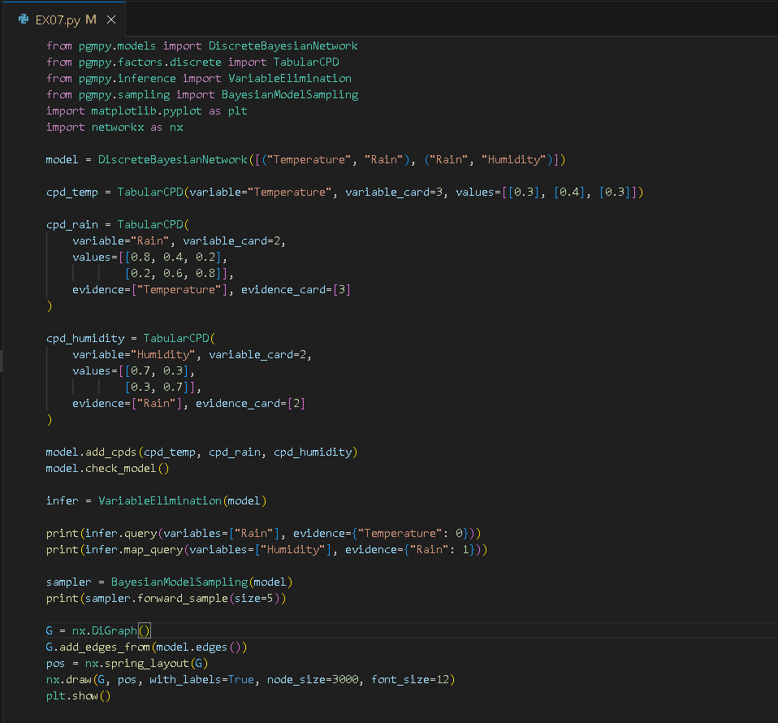

SCREENSHOT OF OUTPUT
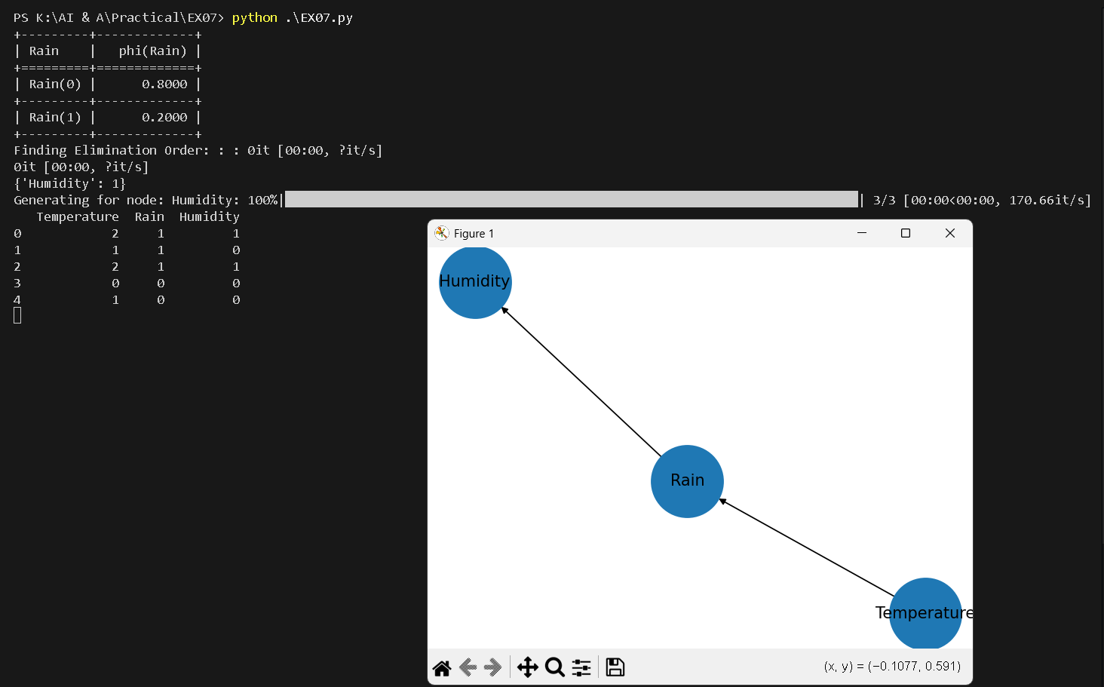

POST-LAB QUESTIONS (Write the answers in your AI and Automation Notebook)
- How do Conditional Probability Distributions (CPDs) define relationships in a Bayesian Network?
CPDs define relationships by quantifying how the probability of each variable depends on its parent nodes, capturing conditional dependencies within the Bayesian Network.

- What is the difference between querying probabilities and MAP prediction in inference?
Querying probabilities finds likelihoods of events given evidence, while MAP prediction identifies the most probable overall assignment of variables based on available data.

- How does Bayesian reasoning handle uncertainty compare to rule-based systems?
Bayesian reasoning manages uncertainty probabilistically, updating beliefs with evidence, whereas rule-based systems rely on fixed logical rules without probabilistic flexibility.

- Explain how adding more variables and dependencies affects the complexity of the network.
Adding variables and dependencies increases network complexity exponentially, making computation, storage, and inference more difficult due to larger probability tables and interdependencies.

- Suggest two domains where Bayesian Networks can be applied effectively.
Bayesian Networks are effectively applied in medical diagnosis for disease prediction and autonomous systems for decision-making under uncertain environmental conditions.

RESULT:
The Bayesian Network was successfully implemented in Python. Variables and dependencies were defined, CPDs were added, and the model was validated. Inference queries were performed to compute probabilities and predictions. Visualization was generated, clearly showing how nodes and edges represent dependencies.

ASSESSMENT (Write in your lab notebook)
Description | Max Marks | Marks Awarded
Pre Lab Exercise | 5
In Lab Exercise | 10
Post Lab Exercise | 5
Viva | 10
Total | 30
Faculty Signature

